**SPREADSHEET PROJECT**

**ZOMATO RESTAURANTS**



**Rahul Jha**

**ZOMATO RESTAURANTS PROJECT**

**Objective Questions**:

1. **What is the total no. of tables present in the data?**

2 Tables

Table 1: Raw data – All information about restaurants

Table 2 : Country Description – Country code and Country name

2.**What is the total no. of attributes present in the data?**

Each column is considered an attribute, so the data contains 22 attributes. Although "Country Code" appears in both the 'Raw Data' table and the "Country Description" table, they are treated as distinct attributes due to their presence in separate tables. Columns with the same name but in different tables are viewed independently because each table represents a unique entity.

Sheet 1: Raw data

* **Restaurant ID:** Unique identifier for each restaurant.
* **Restaurant Name:** The name of the restaurant.
* **Country Code:** Country code of the location where the restaurant is situated.
* **City:** The city where the restaurant is located.
* **Address:** The specific address of the restaurant.
* **Locality:** The locality or neighbourhood where the restaurant is situated.
* **Locality Verbose:** Detailed information about the locality.
* **Longitude:** The geographical longitude coordinate of the restaurant.
* **Latitude:** The geographical latitude coordinate of the restaurant.
* **Cuisines:** The type of cuisine offered by the restaurant.
* **Currency:** The currency used for transactions in the restaurant.
* **Has_Table_booking:** Indicates whether the restaurant has a table booking option (Yes/No).
* **Has_Online_delivery:** Indicates whether the restaurant offers online delivery (Yes/No).
* **Is_delivering_now:** Indicates whether the restaurant is currently delivering (Yes/No).
* **Switch_to_order_menu:** Indicates whether users can switch to the order menu (Yes/No).
* **Price_range:** A numeric value indicating the price range category of the restaurant.
* **Votes:** The number of votes or ratings/(feedback) received by the restaurant.
* **Average_Cost_for_two:** The average cost for two people dining at the restaurant.
* **Rating:** The overall rating of the restaurant is based on user reviews.
* **Datekey_opening:** The date when the restaurant was opened.

Sheet 2: Country description

**CountryCode:** Country code of the location where the restaurant is situated.

**Country name: Respective** country for given country code.

**3.How many categorical columns are there in the data? [Search about categorical and continuous data, and try to answer this question]**

Categorical data consists of discrete values that fall into distinct categories or groups, and they often include text values or codes. So, there are 15 categorical columns and that are following:

1.**Restaurant Name:** The name of the restaurant.

2.**CountryCode:** Country code of the location where the restaurant is situated.

3.**City:** The city where the restaurant is located.

4.**Address:** The specific address of the restaurant.

5.**Locality:** The locality or neighbourhood where the restaurant is situated.

6.**Locality Verbose:** Detailed information about the locality.

7.**Cuisines:** The type of cuisine offered by the restaurant.

8.**Currency:** The currency used for transactions in the restaurant.

9. **Has_Table_booking:** Indicates whether the restaurant has a table booking option (Yes/No).

10. **Has_Online_delivery:** Indicates whether the restaurant offers online delivery (Yes/No).

11.**Is_delivering_now:** Indicates whether the restaurant is currently delivering (Yes/No).

12.**Switch_to_order_menu:** Indicates whether users can switch to the order menu (Yes/No).

13.**Datekey_opening:** The date when the restaurant was opened.

14. **CountryCode:** Country code of the location where the restaurant is situated.

15. **Country name: Respective** country for given country code.

**4.The data consists of some inconsistent and missing values so ensure that the data used for further analysis is cleaned.**

**Identify and handling missing values**

**1.Cuisines**

There were 9 missing values

How I find it:

* Find and S elect
* Go to Special
* Blanks

All the blank cells got Highlighted with green colour. Applied ‘Filter by color’ on Cuisines to check Blank Cells. Then deleted the rows.

All the 9 missing values belong to country code – 216. So, created two pivot tables

Table 1: 'Objective answers'!$A$3

* Rows – Country Code
* Values – Distinct count of restaurants id and averages
* Output – Restaurants count is 434 and Average rating is 4.0

Table 2:

* Rows – Cuisines
* Columns – Country code
* Values – Avg. rating
* Output – Blank restaurants is **4.011290323**

Average of all restaurants is approximately equal to average of restaurants with blank cuisines. So, removing these 9 restaurants from country code - 216 will not affect the whole dataset.

**Inconsistent Values**

1.**Restaurants Id**

There is inconsistency in restaurants id.

* I checked maximum length of restaurants Id, and it comes out to be 8.

FORMULA: =MAX(LEN(A2:A9552))

* Then applied conditional formatting in which applied the rule to highlight the restaurants ids with length less than 8.

RULE: =LEN(A1) <8

* To make all the restaurants ids in same length, Formatted the cells in a custom format of “00000000”

2**. Leading and Trailing spaces**

* Selected the whole dataset and used conditional formatting with a new rule.

RULE: =LEN(A1)<>TRIM(LEN(A1))

* Address, Locality, Locality Verbose had extra spaces in values. So, by using TRIM function I make it consistent.

**3.Pre-Processing – added column**

* **Country:** Added the country for respective country code by using V-lookup Function. This column make analysis better.

=VLOOKUP('Raw Data'!C2,'country description'!$A$2:$B$16,2,0)

* Opening_Month and Opening_year: Extracted the opening year and opening month from ‘Date key opening’ using TEXT function.

=TEXT(DATEVALUE(SUBSTITUTE(T2, "_", "/")), "yyyy")

=TEXT(DATEVALUE(SUBSTITUTE(T2, "_", "/")), "mmmm")

* State: Identified the state name from cities name. This will help us in understanding restaurants density in countries.
* Average cost for two in INR – Changed the ‘average price for two’ currency into INR.This will help us to know the average value in the form of one country.

**5.Using the LookUp functions, fill up the countries in the original data using the country code.**

To fill up the countries in the original data using country code that is present in Country description sheet will require use of VLOOKUP Function.

=VLOOKUP(lookup value,table array,column index number)

=VLOOKUP('Raw Data'!C2,'country description'!$A$2:$B$16,2,0)

**6.Create a table to represent the number of restaurants opened in each country.**

**PIVOT TABLE**: Objective answers'!$Z$28

Rows – country

|  |  |
| --- | --- |
| **Country** | **Count of RestaurantID** |
| Australia | 24 |
| Brazil | 60 |
| Canada | 4 |
| India | 8652 |
| Indonesia | 21 |
| New Zealand | 40 |
| Philippines | 22 |
| Qatar | 20 |
| Singapore | 20 |
| South Africa | 60 |
| Sri Lanka | 20 |
| Turkey | 34 |
| United Arab Emirates | 60 |
| United Kingdom | 80 |
| United States of America | 434 |
| **Grand Total** | **9551** |

Values – Count of Restaurants_ID

**Observation/ Result:** Total Restaurants = 9552

India has highest number of Restaurants = 8652

Canda has lowest number of Restaurants = 4

**7.Also, the management wants to look at the number of restaurants opened each year, so provide them with something here.**

**Pivot Table**: Rows – Opening_year

Values – Count of Restaurants_ID

**Observation/Result:** Year 2018 records the highest number of restaurants opened.

|  |  |
| --- | --- |
| **Year of opening** | **Count of RestaurantID** |
| 2010 | 1080 |
| 2011 | 1098 |
| 2012 | 1022 |
| 2013 | 1061 |
| 2014 | 1051 |
| 2015 | 1024 |
| 2016 | 1027 |
| 2017 | 1086 |
| 2018 | 1102 |
| **Grand Total** | **9551** |

**8.What is the total number of restaurants in India in the price range of 4?**

By using COUNTIFS FUNCTION: =COUNTIFS('Raw Data'!$D:$D,"India",'Raw Data'!$Q:$Q,4)

Answer: 388

Reference sheet: Raw data

**9.What is the average number of voters for the restaurants in each country according to the data?**

Used Pivot table to find average numbers of voters for the restaurants in each country.

**Rows**: Country

**Values**: Average of Votes

**Observation and Result:** Indonesia has the highest votes average, which means customers are very interactive with Restaurants and Brazil has the lowest average votes.

**Reference :** Objective answers sheet

|  |  |
| --- | --- |
| **Row Labels** | **Average of Votes** |
| Australia | 111.42 |
| Brazil | 19.62 |
| Canada | 103.00 |
| India | 137.21 |
| Indonesia | 772.10 |
| New Zealand | 243.03 |
| Philippines | 407.41 |
| Qatar | 163.80 |
| Singapore | 31.90 |
| South Africa | 315.17 |
| Sri Lanka | 146.45 |
| Turkey | 431.47 |
| United Arab Emirates | 493.52 |
| United Kingdom | 205.49 |
| United States of America | 428.22 |
| **Grand Total** | **156.91** |

**10.Calculate the average rating for all the restaurants that have price_range < 4 and provide online delivery. Use only the “IF” function, Logical Operators, and Aggregation functions to solve this problem. [Note: Don’t use Conditional aggregation in this question.]**

**=AVERAGEIFS('Raw Data'!$U:$U,'Raw Data'!$Q:$Q,"<4",'Raw Data'!$N:$N,"Yes")**

Average rating has been calculated in cell AA9554 i.e., = 3.2738

**11.Using Conditional formatting highlight the rows of restaurants that are located in the countries or cities that you’ve suggested to the management for opening new restaurants.**

Criteria **–**

Mainly 2 factors can be considered for suggesting countries for opening new restaurants;

• Count of restaurants in each country.

• Average rating of restaurants in each country.

These are the following steps I followed to highlight the rows of restaurants that are located in the countries that that I’ve suggested to the management for opening new restaurants:

* Highlight your entire data range.
* Go to the Home tab.
* Click on Conditional Formatting.
* Choose New Rule.
* Use a Formula to Determine Which Cells to Format.
* Use the TRIM and UPPER functions in the formula to eliminate spaces and ignore case sensitivity

=OR(TRIM(UPPER($V2))="CANADA", TRIM(UPPER($V2))="AUSTRALIA", TRIM(UPPER($V2))="PHILIPPINES", TRIM(UPPER($V2))="INDONESIA", TRIM(UPPER($V2))="SOUTH AFRICA")

* Click on the Format button.
* Choose colour .
* Click OK.

**12.Create a new customized price column that consists of the abbreviation/symbol of the currency along with the Average_cost_for_two value. [Use string operations to do this task]**

I created new customized column by using following formula:

=MID (L2, FIND ("(“, L2) +1, FIND (")”, L2)-FIND ("(“, L2)-1) &S2

**Explanation of formula**

* FIND ("(", 12) +1: Finds the position of the opening parenthesis and adds 1 to get the position of the first character after the opening parenthesis.
* FIND (“) T2): Finds the position of the closing parenthesis.
* FIND (")", T2)-FIND ("(", T2)-1: Calculates the number of characters between the opening and closing parenthesis.

**13. How can you create an array formula in Excel or Google Sheets to count the number of restaurants listed that do not offer online delivery, are in the lowest price range, and have an average cost for two people less than or equal to 250 Indian Rupees?**

* The currency conversion is calculated from sheet named ‘Currency_conversion’ and vlook up in the current sheet and convert all the avg_cost to INR in column AC (‘Average_Cost_for_two(INR)’).
* The array fn is calculated get the result based on the mentioned condition, using the formula, {=COUNTIFS('Raw Data'!$N$2:$N$9552,"No",'Raw Data'!$Q$2:$Q$9552,1,'Raw Data'!$V$2:$V$9552,"<=250")}in column AB of ‘8,10,12,13. Raw Data’ sheet in cell AF4.
* And the result is 1694.

After typing the formula, I press Ctrl + Shift + Enter to confirm it as an array formula.

**Explanation of the Formula**

* ($N$2:$N$9552="No"): Checks if the restaurant does not offer online delivery.
* ($Q$2:$Q$9552 =1): Checks if the restaurant is in the lowest price range (assuming 1 indicates the lowest).
* ($V$2:$V$9552<=250): Checks if the average cost for two in INR is less than or equal to 250.
* COUNTIFS is used to find value by checking above conditions.

**Subjective Question:**

1. **Suggest a few countries where the team can open newer restaurants with lesser competition. Which visualization/technique will you use here to justify the suggestions?**

To determine countries where team can open newer restaurants with lesser competition, I used following parameters.

Ans -

1. Count of Restaurants in each country
2. Average rating of each Country
3. Average Of Average-cost-for-two converted in common currency in INR

I have created pivot table for analysing the above data

1. **Count of restaurants in each country**

|  |  |
| --- | --- |
| **Row Labels** | **Count of Restaurant ID** |
| Australia | 24 |
| Brazil | 60 |
| Canada | 4 |
| India | 8652 |
| Indonesia | 21 |
| New Zealand | 40 |
| Philippines | 22 |
| Qatar | 20 |
| Singapore | 20 |
| South Africa | 60 |
| Sri Lanka | 20 |
| Turkey | 34 |
| United Arab Emirates | 60 |
| United Kingdom | 80 |
| United States of America | 434 |
| **Grand Total** | **9551** |

1. **Average rating of each country**

|  |  |
| --- | --- |
| **Row Labels** | **Average of Rating** |
| Australia | 3.66 |
| Brazil | 3.85 |
| Canada | 3.58 |
| India | 2.77 |
| Indonesia | 4.30 |
| New Zealand | 4.26 |
| Philippines | 4.47 |
| Qatar | 4.06 |
| Singapore | 3.58 |
| South Africa | 4.21 |
| Sri Lanka | 3.87 |
| Turkey | 4.30 |
| United Arab Emirates | 4.23 |
| United Kingdom | 4.10 |
| United States of America | 4.01 |
| **Grand Total** | **2.89** |

1. **Average of Average-cost-for-two in common currency converted in INR of each country**

|  |  |
| --- | --- |
| **Row Labels** | **Average of Avg. customised price column in INR of each country** |
| Australia | ₹ 1,353.48 |
| Brazil | ₹ 2,125.04 |
| Canada | ₹ 2,292.45 |
| India | ₹ 623.37 |
| Indonesia | ₹ 1,490.31 |
| New Zealand | ₹ 3,620.72 |
| Philippines | ₹ 2,410.23 |
| Qatar | ₹ 5,314.06 |
| Singapore | ₹ 10,505.34 |
| South Africa | ₹ 2,014.72 |
| Sri Lanka | ₹ 688.75 |
| Turkey | ₹ 184.98 |
| United Arab Emirates | ₹ 3,927.43 |
| United Kingdom | ₹ 5,591.19 |
| United States of America | ₹ 2,266.34 |
| **Grand Total** | **₹ 828.77** |

* **Approach**

1. For the first approach I have went with finding the countries with fewer restaurants. Lesser restaurants mean’s lesser competition.
2. For the second approach I have done country wise average rating. Lesser the Rating higher the chance of us establishing quality restaurants.
3. For the third approach I have done country wise average cost of two people. This approach will help us in Pricing strategy, understanding market positioning, identifying market gaps, and investment decisions.

* **Observation**

1. **Count of restaurants**

The count of restaurants indicates market competition. High count shows high demand and strong competition while on the other hand low count shows a marginalised market with potential of growth.

* **Canada:**  Largest in size and it has only 4 restaurants. Thus, the competition is less.
* **Australia:**  2nd largest country and has only 24 restaurants.
* **Indonesia:** It has 21 restaurants only i.e. a smaller number of restaurants opened here as compared to area. So here is opportunity to think about opening newer restaurants.
* **South Africa:** It has 60 restaurantsin total but the area of South Africa is large so we can think to open restaurants in SA depending on rating and average cost in INR and as well as on average votes.
* **Philippines:**  It has only 22 restaurants.

1. **Average rating of Countries**

It is important to see the current rating of restaurants to make the marketing strategies and analyse the performance. A high rate gives us the information of high expectation and a low rate shows the chances of opportunity to deliver a finer quality.

* Low Rating: There need to be improvements.

Example - Australia, Canada

* High Rating: Such countries hold high market demand.

Example – Indonesia, Philippines

* Australia and Canada have slightly low rating and low customers interaction so both these countries hold high chances of improvements.
* Indonesia, Philippines and South Africa have good rating and more customers interaction so here is high chances of market demand.

1. **Average of Average cost-for-two in common currency converted in INR of each country**

Converting the **average cost for two** into a common currency like INR helps compare markets fairly when exploring new restaurant locations. It reveals which countries are **premium**, **mid-tier**, or **budget-friendly**, allowing businesses to align pricing with local expectations. When combined with **ratings** and **votes**, it shows where customers are willing to pay more for quality. High INR-adjusted cost with strong ratings signals a **profitable premium market**, while low cost with high votes may indicate **volume potential**. This insight guides **menu pricing, target audience, and positioning**, ensuring smarter, data-driven expansion into competitive or emerging markets.

| **Reason** | **Explanation** | **Example/Impact** |
| --- | --- | --- |
| 1. **Detect Value vs. Cost** | **See if countries offer higher value at lower or higher prices** | **Singapore: lower cost, high rating** |
| 1. **Smarter Pricing for Entry** | **Helps decide pricing for new restaurants in that market** | **Launch with ₹1,500 meals in mid-tier countries** |
| 1. **Market Segmentation** | **Group countries into value/premium based on INR-adjusted pricing** | **India = budget; Canada = premium** |
| 1. **ROI-Oriented Strategy** | **Align cost, rating, and volume for margin planning** | **Target UAE for optimal rating-cost balance** |

* **Canada**

**INR-adjusted cost: ₹2200+(High), meaning it supports premium pricing**

* **Indonesia**

**INR-adjusted cost: ₹700–₹1500 (low)**

* **Philippines**

**INR-adjusted cost: ₹2400+ (High)**

* **Suggestions:**

From the insights we have gathered we got some common countries like for opening new restaurants

**1. Canada**

• Number of Restaurants: 4 (Lowest)

• Average Rating: 3.58 (Low)

• Average of Average Cost for Two: Rs. 2292.45

**2. Australia**

* Number ofRestaurants**:** 24 (Low)
* Average Rating**:** 3.66 (Moderate-Low)
* Average of Average Cost for Two**:** Rs. 1353.48

**3. Philippines**

• Number of Restaurants: 22 (Low)

• Average Rating: 4.47 (High)

• Average of Average Cost for Two: Rs. 2410.23

**4. Indonesia**

• Number of Restaurants: 21 (Low)

• Average Rating: 4.30 (Moderate-High)

• Average of Average Cost for Two: Rs. 1490.31

**5. South Africa**

• Number of Restaurants: 60 (High)

• Average Rating: 4.21 (Moderate-High)

• Average of Average Cost for Two: Rs. 2014.72

**How This Was Determined**

* Countries with lower competition (fewer restaurants)
* Average of Average-cost-for-two converted into INR of each country
* Rating ≥ 3.5 and votes ≥ median and count of restaurants.
* A balance of market potential, price tolerance, and user satisfaction

1. **Come up with the names of States and cities in the suggested countries suitable for opening restaurants.**

* To come up with the name of cities and states, I observed number of restaurants in suggested country and their respective cities. So, Countries and cities having a smaller number of restaurants and good rating and Average of average cost for two in INR will have high potential of expanding restaurants.

* **Insights:**

1. In Australia we get almost same number of restaurants in each city, we get a varied amount of average rating and have low average cost for two.
2. In Canada we get 1 restaurant in each city, vineland station stands out in the average rating rest all have low rating, except vineland station all have low average cost of two.
3. In Indonesia Bandung and Tangerang are the cities which have less restaurant, every city has almost same rating, and Average of average cost of two.
4. In Philippines we get 1 restaurant each in 2 cities with a rating of 4.5 and 4.8 i.e. high and an average of average cost for two in a budget friendly manner.
5. In Soth Africa we get 2 cities i.e. Inner city and Randburg with 1 and 2 restaurants count i.e. very low as compared to other cities and also have rating of 4.9 and 4.3 i.e. high with mid-tier budget for Average of average cost for two in INR.

**How We Selected States and Cities for Expansion**

* Analysed **Average of** **average cost for two** (converted to INR) to identify pricing tiers
* Evaluated **average customer ratings** to assess satisfaction and engagement
* Selected **cities with high urban populations** and strong economic activity
* Prioritized areas with **diverse demographics** and growing demand for global cuisines
* Considered **existing restaurant density** to avoid oversaturated markets
* Focused on **tech-savvy regions** with active food delivery and app usage
* Included **tourist-friendly cities** for consistent footfall and exposure
* Final picks balance **cost efficiency, competition, and consumer potential**
* **Suggestions:**

1. In Australia the cities I would recommend are
2. Beechworth
3. Palm Cove
4. Tanunda
5. In Canada
6. Vineland station
7. In Indonesia
8. Bandung
9. Tangerang
10. In Philippines

a) Quezon city

1. Tagaytay city
2. In South Africa
3. Inner city
4. Randburg

These cities are easy to approach as they have airports, railway stations, public transports for travelling and are tourist friendly.

* I have highlighted all the cities name present in suggested countries.

|  |  |  |
| --- | --- | --- |
| **Row Labels** | **Count of Restaurant ID** | **Average of Rating** |
| **Australia** | **24** | **3.658333333** |
| Armidale | 1 | 3.5 |
| Balingup | 1 | 3.2 |
| Beechworth | 1 | 4.6 |
| Dicky Beach | 1 | 3.6 |
| East Ballina | 1 | 4.1 |
| Flaxton | 1 | 3.5 |
| Forrest | 1 | 3.7 |
| Hepburn Springs | 2 | 3.8 |
| Huskisson | 1 | 4.1 |
| Inverloch | 1 | 3.7 |
| Lakes Entrance | 1 | 3.8 |
| Lorn | 1 | 3.6 |
| Macedon | 1 | 3.5 |
| Mayfield | 1 | 2.9 |
| Middleton Beach | 1 | 3.8 |
| Montville | 1 | 2.4 |
| Palm Cove | 1 | 4.4 |
| Paynesville | 1 | 2.6 |
| Penola | 1 | 3.4 |
| Phillip Island | 1 | 3.7 |
| Tanunda | 1 | 4.4 |
| Trentham East | 1 | 4.1 |
| Victor Harbor | 1 | 3.6 |
| **Brazil** | **60** | **3.846666667** |
| **Canada** | **4** | **3.575** |
| Chatham-Kent | 1 | 3.7 |
| Consort | 1 | 3 |
| Vineland Station | 1 | 4.3 |
| Yorkton | 1 | 3.3 |
| **India** | **8652** | **2.770550162** |
| **Indonesia** | **21** | **4.295238095** |
| Bandung | 1 | 4.2 |
| Bogor | 2 | 3.85 |
| Jakarta | 16 | 4.35625 |
| Tangerang | 2 | 4.3 |
| **New Zealand** | **40** | **4.2625** |
| **Philippines** | **22** | **4.468181818** |
| Makati City | 2 | 4.65 |
| Mandaluyong City | 4 | 4.625 |
| Pasay City | 3 | 4.366666667 |
| Pasig City | 3 | 4.633333333 |
| Quezon City | 1 | 4.8 |
| San Juan City | 2 | 4.25 |
| Santa Rosa | 2 | 3.8 |
| Tagaytay City | 1 | 4.5 |
| Taguig City | 4 | 4.525 |
| **Qatar** | **20** | **4.06** |
| **Singapore** | **20** | **3.575** |
| **South Africa** | **60** | **4.21** |
| Cape Town | 20 | 4.11 |
| Inner City | 2 | 4.9 |
| Johannesburg | 6 | 4.2 |
| Pretoria | 20 | 4.19 |
| Randburg | 1 | 4.3 |
| Sandton | 11 | 4.3 |
| **Sri Lanka** | **20** | **3.87** |
| **Turkey** | **34** | **4.3** |
| **United Arab Emirates** | **60** | **4.233333333** |
| **United Kingdom** | **80** | **4.1** |
| **United States of America** | **434** | **4.011290323** |
| **Grand Total** | **9551** | **2.89126793** |

Pivot Table : Rows-Country , City

Values- Average rating

|  |  |
| --- | --- |
| **Country** | **Average of Rating** |
| Australia | 3.658333333 |
| Canada | 3.575 |
| Indonesia | 4.295238095 |
| Philippines | 4.468181818 |
| South Africa | 4.21 |

**3.According to the countries you suggested, what is the current quality regarding ratings for restaurants that are open there?**

**Observation:**

* Philippines has the highest average rating, and Canada has the lowest average rating.
* Countries having the highest average rating, suggesting that the quality of restaurants in these countries is high.
* Canada and Australia have relatively lower average rating as compared to other countries listed, indicating that restaurants quality is not high and here it need to be improvement.

**4.Also, what is the current expenditure on food in the suggested countries, so we can keep our financial expenditure in control**?

I created Pivot table + Chart

Rows- Country

Values – Average of average cost for two in INR

|  |  |
| --- | --- |
| **Row Labels** | **Average of Avg. customised price column in INR of each country** |
| Australia | ₹ 1,353.48 |
| Canada | ₹ 2,292.45 |
| Indonesia | ₹ 1,490.31 |
| Philippines | ₹ 2,410.23 |
| South Africa | ₹ 2,014.72 |
| **Grand Total** | **₹ 1,884.41** |

Observation:

1. **Philippines (₹2410.23) and Canada (₹2292.45)** have the **highest average cost** for dining. This indicates that consumers in these countries are likely spending more on meals, which suggests:

* We can afford to spend more on premium services in these regions, such as better quality ingredients, larger marketing campaigns, or upscale dining experiences.
* These markets may sustain **higher price points** for menu items and services, allowing us to invest more without risking financial strain.

1. **Australia (₹1353.48) and Indonesia (₹1490.31)** have moderate average costs compared to the other countries. In these regions003A

* We need to focus on maintaining cost-efficiency and budget friendly. These markets likely demand more value-for-money services, meaning We should control its operational costs.

**5.Come up with the names of restaurants from the recommended states that are our biggest competitors and also those that are rated in the lower brackets, i.e. 1-2 or 2-3.**

* These are the restaurants that are low rated:
* These are the high rated restaurants that are our biggest competitor :

|  |  |  |
| --- | --- | --- |
| **Row Labels** | **Average of Rating** | **Average of Avg. customised price column in INR of each country** |
| **Australia** |  |  |
| Armidale | 3.5 | ₹ 1,124.00 |
| Balingup | 3.2 | ₹ 1,124.00 |
| Beechworth | 4.6 | ₹ 1,124.00 |
| Dicky Beach | 3.6 | ₹ 393.40 |
| East Ballina | 4.1 | ₹ 1,124.00 |
| Flaxton | 3.5 | ₹ 1,686.00 |
| Forrest | 3.7 | ₹ 1,124.00 |
| Hepburn Springs | 3.8 | ₹ 758.70 |
| Huskisson | 4.1 | ₹ 1,124.00 |
| Inverloch | 3.7 | ₹ 393.40 |
| Lakes Entrance | 3.8 | ₹ 393.40 |
| Lorn | 3.6 | ₹ 1,124.00 |
| Macedon | 3.5 | ₹ 1,124.00 |
| Mayfield | 2.9 | ₹ 1,124.00 |
| Middleton Beach | 3.8 | ₹ 1,686.00 |
| Montville | 2.4 | ₹ 1,686.00 |
| Palm Cove | 4.4 | ₹ 1,686.00 |
| Paynesville | 2.6 | ₹ 6,744.00 |
| Penola | 3.4 | ₹ 1,124.00 |
| Phillip Island | 3.7 | ₹ 1,124.00 |
| Tanunda | 4.4 | ₹ 1,686.00 |
| Trentham East | 4.1 | ₹ 1,124.00 |
| Victor Harbor | 3.6 | ₹ 1,124.00 |
| **Canada** |  |  |
| Chatham-Kent | 3.7 | ₹ 1,581.00 |
| Consort | 3 | ₹ 1,581.00 |
| Vineland Station | 4.3 | ₹ 4,426.80 |
| Yorkton | 3.3 | ₹ 1,581.00 |
| **Indonesia** |  |  |
| Bandung | 4.2 | ₹ 795.00 |
| Bogor | 3.85 | ₹ 848.00 |
| Jakarta | 4.35625 | ₹ 1,634.72 |
| Tangerang | 4.3 | ₹ 1,325.00 |
| **New Zealand** |  |  |
| Auckland | 4.275 | ₹ 3,542.86 |
| Wellington City | 4.25 | ₹ 3,698.59 |
| **Philippines** |  |  |
| Makati City | 4.65 | ₹ 1,725.00 |
| Mandaluyong City | 4.625 | ₹ 3,000.00 |
| Pasay City | 4.366666667 | ₹ 5,000.00 |
| Pasig City | 4.633333333 | ₹ 1,400.00 |
| Quezon City | 4.8 | ₹ 1,200.00 |
| San Juan City | 4.25 | ₹ 1,275.00 |
| Santa Rosa | 3.8 | ₹ 1,237.50 |
| Tagaytay City | 4.5 | ₹ 1,800.00 |
| Taguig City | 4.525 | ₹ 2,587.50 |

Criteria:-

**Highlight High Performers (Rating ≥ 4.5)**

→ Use the pivot filter to list restaurants with average ratings ≥ 4.5. These are your benchmark competitors for service level and quality.

**Spot Underperformers (Rating 1 – 3.0)**

→ Filter for ratings between 1 and 3.0 to surface restaurants with weak performance—ideal targets for market intervention or competitive advantage.

**Ensure Sufficient Sample Size (Votes Count ≥ 5)**

→ Only consider restaurants with a reasonable vote count (e.g., ≥ 5) to avoid skewed insights from low-feedback extremes (both high and low ratings).

**City-by-City Contextual Analysis**

→ Apply a city/country filter to control for local market saturation—especially to avoid launching in areas already dominated by high-rated outlets.

**Strategic Opportunity Mapping**

→ Use your findings to:

Avoid saturated areas with many high-rated restaurants.

Prioritise locations with low-rated yet well-reviewed competitors as ideal for market entry with improved offerings.

Explanation:

I have used Pivot Table where I have put Country and restaurant name in rows and in values, I have taken average of rating and average cost of two in Indian Rupees. I have taken City in Filter section.

**Restaurant with biggest competitors:** I have marked the cities in Green which have the biggest competition in the Market.

**Restaurant with weak competition:** I have marked the cities in red which have week competition in the market.

**Recommendations:**

* **Target Weak Competition Areas:** Focus on cities with lower-rated restaurants to establish a foothold and capture market share by providing superior quality and service.
* **Benchmark Against Strong Competitors:** Analyze the strategies of top-rated competitors in high-competition cities to adopt best practices and identify unique differentiators.
* **Strategic Expansion:** Enter high-competition markets cautiously, leveraging unique offerings to stand out.
* **Cost and Quality Optimization:** Ensure competitive pricing and consistent quality to outperform lower-rated competitors.
* **Continuous Monitoring:** Track the performance of competitors regularly to adapt strategies and stay ahead in the market.
* Expand in Low-Rated Areas (Weak Competition)
* **Australia**: Focus on **Montville**, **Mayfield**, **Paynesville**.
* **Canada**: Consider **Consort**.
* Compete Smart in High-Rated Areas (Strong Competition)
* Benchmark against top players in **Quezon City**, **Jakarta**, **Vineland Station**, etc.
* Analyse cuisine, pricing, and customer experience strategies.

**6.Which cuisines should we focus on in the newer restaurants to get better feedback? Does the choice of cuisines affect the restaurant ratings?**

* Approach:-

that I used for this is I created a pivot table with cuisines and then count of restaurants and average rating in values.

* + • Aggregate the data from the three tables (sliced by countries) to identify the average ratings per cuisine.
  + • Identify high-performing cuisines based on the average ratings.
  + • Compare cuisines with lower ratings to assess potential areas for improvement.

|  |  |  |
| --- | --- | --- |
| **Row Labels** | **Count of RestaurantID** | **Average of Rating** |
| Asian | 1 | 2.9 |
| Australian | 1 | 4.1 |
| Bar Food, Modern Australian | 1 | 3.8 |
| Bar Food, Steak | 1 | 3.5 |
| Breakfast, Coffee and Tea | 2 | 3.7 |
| Breakfast, Coffee and Tea, Modern Australian | 1 | 3.7 |
| Breakfast, Modern Australian | 1 | 4.1 |
| Burger, Coffee and Tea, Modern Australian | 1 | 3.7 |
| Cafe | 2 | 3.8 |
| Cafe, Australian | 1 | 3.7 |
| Cafe, Coffee and Tea, Modern Australian | 1 | 3.8 |
| Cafe, Coffee and Tea, Sandwich | 1 | 3.4 |
| Coffee and Tea, Modern Australian | 1 | 2.4 |
| Coffee and Tea, Tapas, Australian | 1 | 3.6 |
| Coffee and Tea, Tea, Modern Australian | 1 | 3.6 |
| Italian, Fusion, Cafe | 1 | 3.8 |
| Mediterranean, Seafood | 1 | 4.4 |
| Modern Australian | 2 | 2.9 |
| Modern Australian, Australian | 1 | 4.4 |
| Pizza, Bar Food | 1 | 4.6 |
| Tea, Modern Australian | 1 | 3.5 |
| **Grand Total** | **24** | **3.658333333** |

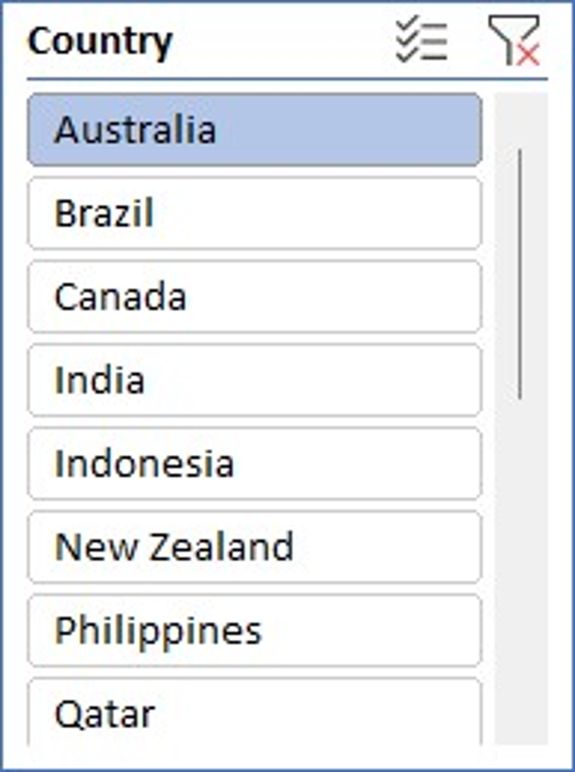 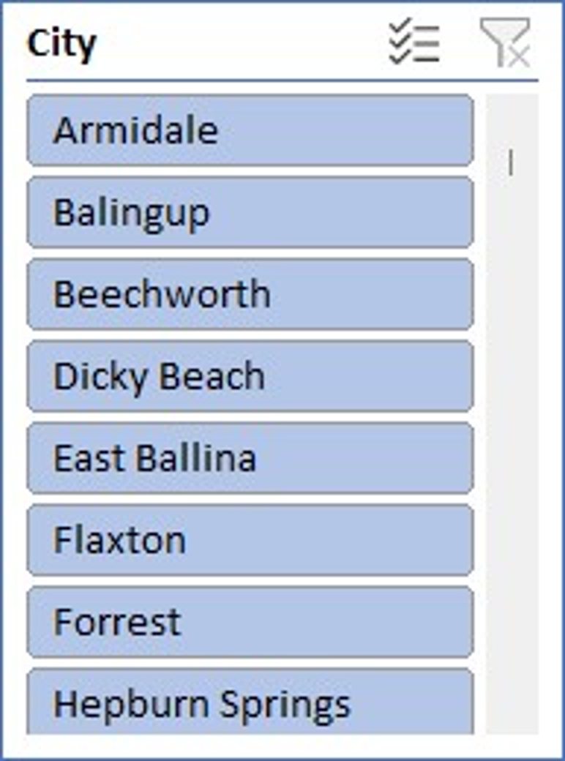

* Insights:-

• High-Performing Cuisines:

* Sunda, Indonesian: This cuisine has the highest aggregated rating of 14.7 across 3 restaurants, indicating strong customer satisfaction.
* Seafood, Western: With a total rating of 7.4 for 2 restaurants, this cuisine also shows promise.
* Italian, Mediterranean, Pizza rated 4.3 across 1 restaurant demonstrates potential.

• Lower-Performing Cuisines:

* Asian: A total of 4.6 ratings for 1 restaurant, indicating room for improvement.
* Cafe, Coffee and Tea, Modern Australian: Received 2.4 ratings, suggesting that this combination may not meet customer expectations.
* Breakfast, Coffee and Tea: Despite having 7.4, individual offerings within this category need careful consideration to avoid dilution of quality.
* Suggestions:-
  + Focus on High-Rated Cuisines: Prioritize developing restaurants with cuisines such as Sunda Indonesian and Seafood Western, as they are currently performing well and could attract more customers.
  + Re-evaluate Lower-Performing Cuisines: Investigate why certain cuisines like Cafe, Coffee and Tea received lower ratings and consider menu adjustments or enhanced customer experiences in these areas.
  + Diversity in Offerings: Consider offering a mix of high-performing cuisines with lower-rated options to cater to diverse customer preferences while gradually improving lower-rated areas.

Customer Feedback Loop: Implement systems to gather customer feedback specifically related to new cuisine offerings to ensure they meet market demand and quality expectations.

**1. Focus on These Cuisines in New Restaurants:**

| **Cuisine** | **Avg Rating** | **Reason** |
| --- | --- | --- |
| Italian | High (>4) | Customers value its variety and presentation. |
| Mexican | High | Often considered fresh and flavorful. |
| Japanese | High | Perceived as premium and authentic. |
| Cafe-style | High | Good for casual, urban crowd. |
| Continental | High | Appeals to diverse palate. |

**2.** Avoid or Reassess Offering:

* Heavily saturated cuisines (e.g., North Indian) unless offering a unique twist.
* Poorly rated cuisines unless backed by strong chefs or a unique concept.

**3.** Yes, Cuisine Affects Ratings:

* The choice of cuisine has a clear impact on restaurant ratings.
* Cuisines with global appeal, healthier perception, or fusion twists tend to be rated higher.

**7.According to our current data, should we go for online delivery and table booking? Does that affect the customer’s ratings?**

I created two pivot table

|  |  |
| --- | --- |
| **Has online delivery** | **Average of Rating** |
| No | 2.754309859 |
| Yes | 3.288004896 |

**Table 1:**

Rows – Has_online_delivery

Values – Average rating of restaurant

|  |  |
| --- | --- |
| **Has Table booking** | **Average of Rating** |
| No | 2.809686644 |
| Yes | 3.482556131 |

**Table 2:**

Rows – Has_Table_booking

Values – Average rating of restaurant

**Conclusion:**

* Restaurants offering online delivery have a significantly higher average rating (3.29) compared to those without (2.75). This suggests that customers value the convenience of online delivery, and it correlates with better ratings.
* Similarly, restaurants that provide table booking options have a much higher average rating (3.48) compared to those that do not (2.81). This indicates that customers appreciate the ability to reserve tables, enhancing their overall dining experience.
* Both online delivery and table booking options appear to positively influence customer ratings. The data clearly shows that implementing these features can lead to higher customer satisfaction and better ratings, which are essential for attracting new customers and retaining existing ones.
* Based on these findings, I should prioritize expanding restaurant partnerships to include those offering online delivery and table booking. This strategy is likely to improve customer ratings and increase overall business performance.

**8.Should the team keep the rate of cuisines higher? Will that affect the feedback? According to our data are the rates of cuisines and ratings, correlated?**

To determine if keeping the rates of cuisines higher will affect feedback, and to analyze the correlation between cuisine rates and ratings using I follows these steps:

* Create a Pivot Table

**Rows**: Cuisines

**Values**: Average_Cost_for_two (set to average) and Rating (set to average)

* Correlation Analysis

Copy the average values from the Pivot Table into a new table.

In an empty cell, I use the CORREL function to calculate the correlation coefficient between average cost and average rating.

Formula: =CORREL(L2:L124,M2:M124) = 0.32372

* Visual Representation

Choose a scatter plot to visualize the relationship between average cost and average rating.

* Observation:
  + - A correlation coefficient close to 1 indicates a strong positive correlation, while a value close to -1 indicates a strong negative correlation. A value around 0 suggests no correlation.
    - Based on the correlation result and the visual representation, correlation is strong and positive, So I recommend that the team can keep the rates higher, as it seems to correlate with better feedback.

**9.What is the distribution of the number of restaurants of different price ranges in all the countries?**

To analyze the distribution of the number of restaurants across different price ranges in various countries I follows these steps:

**Step 1: Create a Pivot Table**

Rows – Country

Column – Price_ range

Values - Restaurant ID

|  |  |  |  |  |
| --- | --- | --- | --- | --- |
| **Count of RestaurantID** | **Column Labels** |  |  |  |
| **Row Labels** | **1** | **2** | **3** | **4** |
| India | 4295 | 2858 | 1111 | 388 |
| United States of America | 136 | 165 | 110 | 23 |
| United Kingdom | 4 | 28 | 32 | 16 |
| Brazil | 2 | 7 | 16 | 35 |
| United Arab Emirates |  | 9 | 29 | 22 |
| South Africa |  | 4 | 17 | 39 |
| New Zealand | 3 | 4 | 17 | 16 |
| Turkey |  | 11 | 18 | 5 |
| Australia | 4 | 14 | 5 | 1 |
| Philippines |  | 1 | 12 | 9 |
| Indonesia |  | 1 | 20 |  |
| Sri Lanka |  | 6 | 11 | 3 |
| Singapore |  | 1 | 5 | 14 |
| Qatar |  | 1 | 5 | 14 |
| Canada |  | 3 |  | 1 |

**Step 2: Create a Pivot Chart**

**Conclusion:**

* The total number of restaurants across all countries is 9,551, with India having the highest count at 8,652. This indicates a strong and diverse dining market in India, where affordability appears to be a key factor.
* **Price Range Distribution**:

Price Range 1 (Budget-Friendly):

India dominates this category with **4,295** restaurants, highlighting the demand for affordable dining options. Other notable countries include the **United States** (136) and **Australia** (4).

Price Range 2:

Again, India leads with **2,858** restaurants. Countries like **Brazil** (7) and **United Kingdom** (28) show moderate counts, suggesting opportunities for mid-range offerings.

Price Range 3:

India has **1,111** restaurants, while Brazil (16) and South Africa (39) demonstrate a mix of mid to high-end dining options.

Price Range 4 (Premium):

Brazil (35) and South Africa (60) indicate a growing market for premium dining, which is also evident in Turkey (34) and the UAE (60).

* Countries like **Turkey**, **South Africa**, and **Indonesia** exhibit a potential for growth in various price segments, particularly in mid to high-end offerings.
* Countries such as **Canada** and **Philippines** have lower total counts, especially in the higher price ranges, suggesting opportunities for Zomato to introduce new restaurant concepts.
* India stands out as a key market due to its vast number of budget-friendly restaurants, indicating a strong demand for affordable dining. The United States and Brazil also present significant opportunities, particularly in higher price ranges.

**10. Explain your approach in brief for suggesting countries/cities in order to open new restaurants, if the objective and subjective questions would have not been given to assist you. [you have to give bullet pointers in order to answer this question]**

Approach for Identifying Countries/Cities for New Restaurant Openings

1. **Comparative Analysis of Restaurant Count**
   * + - * Evaluate the number of existing restaurants in each country relative to their size.
         * Canada: Large land area with only 4 restaurants, indicating minimal competition.
         * Australia: 4th largest country, only 24 restaurants, suggesting a potential market gap.
         * Indonesia: 21 restaurants, low compared to its size, presenting an opportunity for new entries.
         * South Africa: Larger than many countries but only 60 restaurants, indicating room for growth.
         * Philippines: Only 22 restaurants, suggesting less competition.
2. **Average Restaurant Ratings**
   * + - * Analyse current ratings to inform marketing strategies and operational improvements.

Low Ratings:

Australia and Canada show lower ratings, indicating a need for enhancements.

* High Ratings:

Indonesia and Philippines hold higher ratings, reflecting strong market demand.

1. **Average Number of Votes**

* Customer Interaction: High vote counts correlate with customer engagement and stable ratings.
* Low Average Votes:

Australia and Canada exhibit lower customer interaction, leading to potential fluctuations in ratings.

* High Average Votes:

Indonesia, Philippines, and South Africa have higher interaction, indicating consistent demand and stability.

**Observations**

* Improvement Potential: Australia and Canada present opportunities for enhancing service and offerings due to low ratings and interactions.
* Market Demand: Indonesia, Philippines, and South Africa show favourable conditions for new restaurant openings due to higher ratings and customer engagement.